**Diganta Mukherjee**

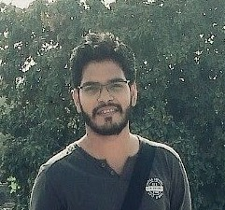

**Personal Details**

**Email ID** - [mukherjeediganta567@gmail.com](mailto:mukherjeediganta567@gmail.com)

**Mobile Number** - 9999818739

**Address** - Flat No-13, S-37, Pandav Nagar, Delhi-92

**Summary**

Highly skilled, committed web development and designing with well managed and functioned codes. Being a fresher, I am looking forward to beginning my career in this ﬁeld with lots of expectations and commitments and will also promote increasing the proﬁts for a prosperous company.

Able to build a web presence from the ground up-from concepts, navigation, layout, and programming to UX/UI.

Fast learner, hard worker, and team player who is proﬁcient in designing and developing a basic website suitable to industrial needs.

**Experience**

**Web Designer/Developer**

Freelancing • Delhi, Delhi 06/2020 - Present

**Skills**

|  |  |  |
| --- | --- | --- |
| HTML5 | CSS3 | JavaScript |
| Bootstrap | Microsoft Powerpoint | Microsoft Word |
| Excel |  |  |

**Education**

* Crampete Pte Ltd.

Certification in Full Stack development • Chennai, Chennai 06/2020

I am currently undergoing certiﬁcation course

* Graduation

IGNOU • Delhi, Delhi 06/2016

Completed my graduation in B.Sc from IGNOU with 72%

* Class XII

Bal Bhavan Public School • Delhi, Delhi 04/2013

Completed my class XII with 69% in Science Stream

**Languages Known**

English Hindi Bengali

**Hobbies**

* Traveling to new places
* Reading history
* Playing cricket

**Official Links**

* Portfolio Link - <https://codig.netlify.app/>
* Linkedin Link - [www.linkedin.com/in/codig-mukherjeediganta](http://www.linkedin.com/in/codig-mukherjeediganta)/